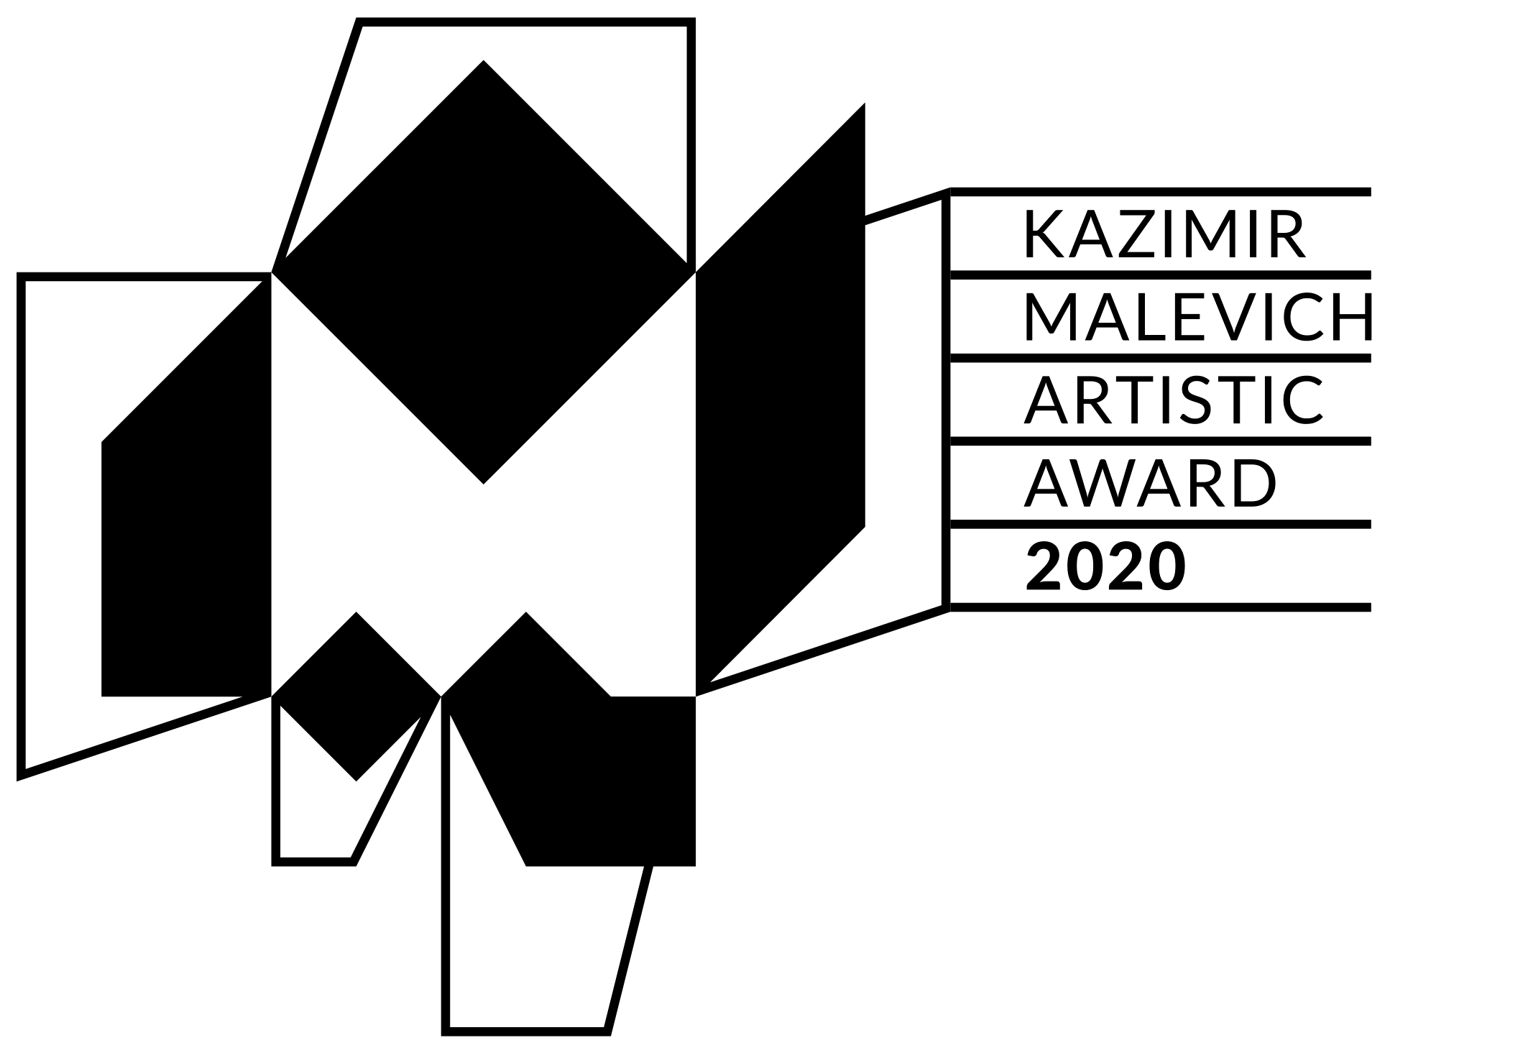
APPLICATION FORM for

THE KAZIMIR MALEVICH ARTISTIC AWARD
founded in 2008 by the Polish Institute in Kyiv
Is given to an Ukrainian artist aged below 40
for their contribution to the contemporary art development. The quality, mastery, achievements and significance of works are assessed.

LAUREATES:
Alevtyna Kakhidze (2008)
Stas Voliazlovsky (2010)
Zhanna Kadyrova (2012)
Lada Nakonechna (2014)
Mykyta Kadan (2016)
Ivan Svitlychnyi (2018)

full name of the nominating institution

Postal adress

Phone number

E-mail

Contact person

NOMINATED ARTIST

NOMINEE JUSTIFICATION (up to 500 words)

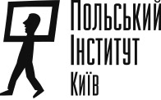
Please sent the application form as a part of one
pdf file, titled MALEWICZ 2020_Name_Surname.pdf,
and should contain also a CV and artistic portfolio (max.10 MB)
at olena.zoc@instytutpolski.org till 08.11.2020
The subject line should read MALEWICZ 2020

