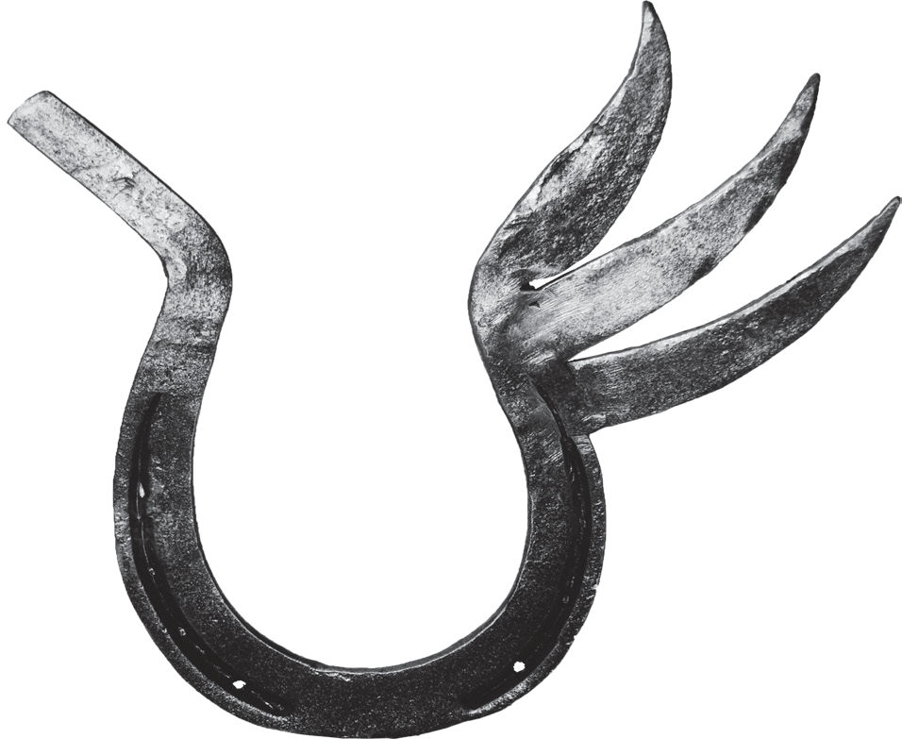
Regulations of
The 17th International Meetings with Monodrama

for “THE GOLDEN HORSESHOE
OF PEGASUS”
in Suwałki

When and where?
Competition will take place from 3nd to 5th December 2020 at Suwalki Culture Centre, 5 Papieża Jana Pawła II Street

Who can participate?
We invite talented youth and adults in the following age categories: youth aged 16–19 as well as adults, amateurs and professionals (students from theatre schools, professional actors) operating in countries around the world.

What do you need to prepare?
A monodram based on any literary work. It is allowed to use a voice from off-line, multimedia and live music. The performance should have a verbal or visual layer, legible for a foreign language recipient. The duration of the performance:
- up to 30 min, performers aged 16–19,
- up to 45 min, amateurs adult performers,
- up to 60 min, professional actors.

How to apply?

Participant, instructor, director, school, leading institution or a parent shall submit until 30th of October 2020 (first term) and in case of vacancies until 10th of November 2020 (second term) to the Organizational Office,
a DVD with the recorded performance together with the filled out application form. Jury shall point out the qualitied performances.
The Organizer will inform the applicant shall be informed by the decision by e-mail or by phone until 2nd^{t} of November 2020 (in case of the first term) and until 12 of November (in case of the second term).

Props.
Standard only, needed to perform the performance: table, chairs, hanger and mirror (provided that they will be included in Annex 1 to the participation card).

Evaluation criteria.
The jury will take into account the invisible interference of the instructor/director, the truth of the statement (compliance with the personality and age of the performer), the ability to convey the content, selection of the repertoire, novelty, originality, diction, justified expression of gesture, movement, facial expressions and words.

Who bears the cost of the participant’s stay?
The applying institution, youth custodians or adult participants shall cover travel costs by themselves and additionally pay accreditation to the Organizer which shall cover the costs of accommodation, meals and festival memorabilia in the amount of PLN 300 (per person).
The accreditation shall be paid on the account number: 22 1240 5211 1111
0010 8508 6721 until 30th of November 2020 with a note PEGAZ 2020.

Awards.
The laureates shall receive a financial awards as well as statuettes and diplomas upon the Jury’s decision which is final.
The Organizer obliges award winners to collect the prizes in person.

Personal data protection.
  - The administrator of personal data, collected from the Meetings, is Suwałki Culture Centre based in Suwałki, at 5 Papieża Jana Pawła II.
  - Personal Data Administrator has appointed the Personal Data Inspector (contact e-mail: dorota.sklodowska@soksuwalki.eu) who oversees the correctness of personal data.
  - Personal data of the participants will be processed in order to organize the 17th International Meetings with Monodram for “The Golden Horseshoe of Pegasus” for the archive, promotion and marketing purposes.
  - Providing personal data is is voluntary, according to the Article
6 a) but it is necessary to to participate in Meetings.
  - The participant has the right to access its data content and within the law has the right to rectify the data, delete it, limit its processing, the right to transfer data, the right to raise objections, the right to withdraw consent at any time, the right to make a complaint to the supervisory body.
  - The Meeting participant allows to use, disseminate the image by Suwałki Culture Centre free of charge for the needs of organization, documentation and promotion purposes.
  - Due to the spread of SQARS-CoV-2 each participant of the Meetings is required to submit a written health declaration on the day of the Festival.
  - The Organizer declares that the data of Meeting participants will not be processed in an automated manner and will not be pro- filed.
  - The participants’ data will not be made available to external entities, except for situations provided by law.
  - The participants’ data will be kept for the period necessary to achieve the above-mentioned goals.
  - Participants of the Meetings have the right to lodge a complaint with the President of the Office for Personal Data Protection.

10.Consent to registration and media broadcast.
Institutions reporting the groups to participate in the Meetings as well as the authors and performers of the works agree to photographic, audio and video recordings as well as agree to have it broadcast by television without financial claims associated with above mentioned and to use the resulting documentation for methodological and promotional purposes.
- Additional information. Meetings Organizational Office: Suwałki Culture Centre
5 Papieża Jana Pawła II Street 16-400 Suwałki, Poland
tel. 0048 87 563 85 525
www.soksuwalki.eu/o-zlota-podkowe-pegaza

Artistic Director of the Meetings:
Grażyna Filipowicz-Karp Mobile Telephone +48 513 625 229
e-mail: grazyna.filipowicz_karp@soksuwalki.eu

